To implement a FIFO (First-In-First-Out) data structure with O(1) lookup for both enqueue, dequeue, and lookup, you can use a combination of the following data structures:
- A doubly linked list to maintain the order of elements for FIFO operations (enqueue and dequeue).
- A hash map (dictionary) to provide O(1) lookup for elements by their keys.
This design ensures:
- O(1) enqueue: Insert at the tail of the linked list.
- O(1) dequeue: Remove from the head of the linked list.
- O(1) lookup: Use the hash map to locate elements quickly.

Implementation
Here’s an example implementation in Java:
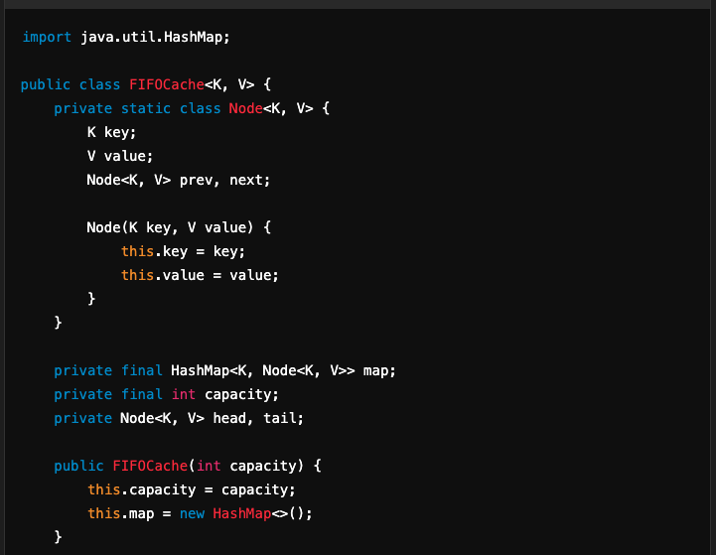
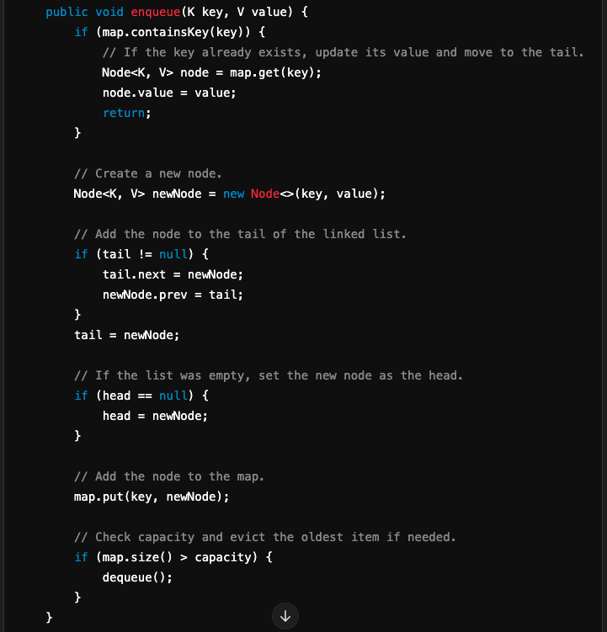
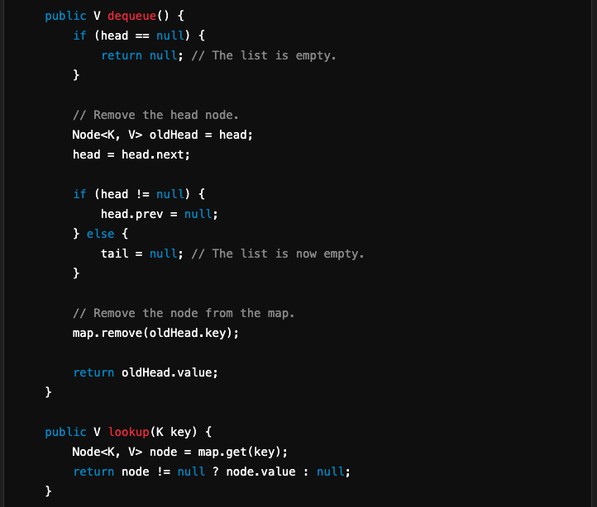
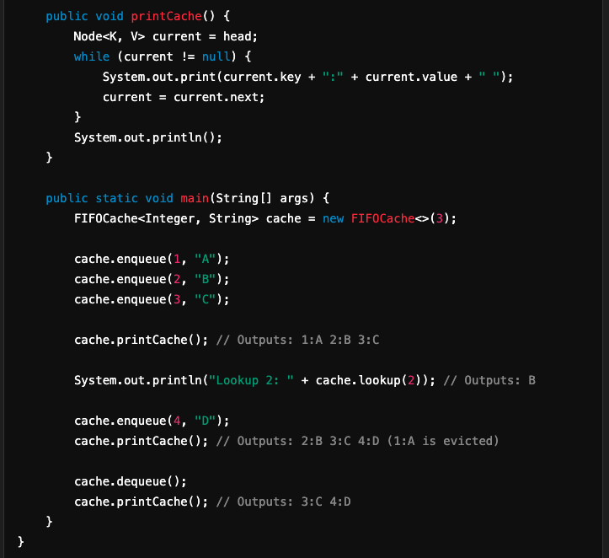

Explanation
- Doubly Linked List:
  - Maintains the order of elements for FIFO behavior.
  - Allows for quick removal from the head (dequeue) and addition at the tail (enqueue).
- Hash Map:
  - Maps keys to their corresponding nodes in the linked list.
  - Provides O(1) lookup for elements.
- Capacity Management:
  - When the capacity is exceeded, the oldest element (at the head) is removed.

Key Operations and Their Complexity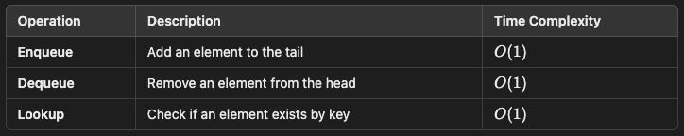
This approach is ideal for scenarios like implementing caches (e.g., FIFO Cache) or task queues with quick lookups.

